**Design and Development of a Mobile Robot Navigation System with an Inertial Measurement Unit (IMU) based on Fuzzy Logic and a Proportional Integral Derivative (PID) Control Approach**

1st Faiz Daffa Ulhaq1, 2nd Achmad Zuchriadi P.2, and 3rd Ferdyanto3

1,2,3Electrical Engineering, Universitas Pembangunan Nasional Veteran Jakarta

faizdafa15@gmail.com

Received 1 November 201x **|** Revised 1 Desember 201x **|** Accepted 1 Januari 201x

## Abstract

*Mobile robots have unique characteristics that can move from one place to another. Mobile robot navigation systems are challenging because they must move autonomously without colliding with objects around them. Fuzzy logic is used to solve problems in inappropriate aspects. Combining fuzzy logic and PID control systems can improve robot navigation performance. The PID control system stabilizes the Inertial Measurement Unit (IMU) sensor readings according to the final angle setpoint from the fuzzy output so that the robot can move straight. The results of fuzzy logic testing using 100 data experiments each obtained 97% accuracy and 97% precision. The results of PID tuning using the Ziegler-Nichols 2 method still need to be improved by increasing the Kd value to reduce the steady-state error value. They combine fuzzy logic and PID by providing two different obstacles so that the robot can adapt to avoid obstacles.*

***Keywords****: Mobile Robot, Fuzzy Logic, PID, Avoidance Obstacle.*

## INTRODUCTION

Robots are increasingly becoming more autonomous, adaptable, and collaborative over time so that they can interact with each other and work together with humans (Galin & Meshcheryakov, 2019). Among the various types of robots, mobile robots have the unique characteristic of moving from one place to another. Mobile robot navigation systems are challenging because they must move autonomously without colliding with objects around them (Achmad & Karsiti, 2007).

The application of mobile robots is essential in various fields, especially in production and manufacturing processes in industry. Combining fuzzy logic and PID control systems in mobile robot navigation systems is very effective, especially in changing environments. The system in this research uses an ultrasonic sensor to measure the distance of objects around it. The robot's direction decisions are determined by fuzzy logic in the form of angles based on ultrasonic sensor readings. Then, the angular position of the robot is controlled by the PID control system to stabilize the Inertial Measurement Unit (IMU) sensor reading according to the setpoint in the form of an angle from the fuzzy output so that the robot can move straight.

## METHOD

### Takagi-Sugeno-Kang Fuzzy Logic

Fuzzy logic is a development of Boolean logic by Lotfi Zadeh in 1965, which is based on the mathematical theory of fuzzy sets, which is a generalization of classical set theory. Fuzzy logic allows inaccuracies and uncertainties to be accounted for, thus providing the ability to solve complex problems (Hellmann, 2001).

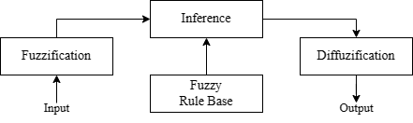

**Figure 1. Fuzzy Logic Structure**

Fuzzy Takagi-Sugeno-Kang (TSK) is a fuzzy logic technique that can model a control system with an ideal response. This method combines linear and nonlinear models to solve complex and unpredictable system problems (Al-Mallah et al., 2022). The concept of fuzzy TSK is that the output of this fuzzy system is in the form of a set of fuzzy singletons. TSK has a rule base in a series of "If-Then" expressions in the fuzzy inference process (Najmurrokhman et al., 2018).

1. Fuzzification

Fuzzification is a set membership function of ultrasonic sensor input, with each ultrasonic sensor reading being grouped into near, medium, and far for each left, front, and right ultrasonic, as shown in Figure 2.

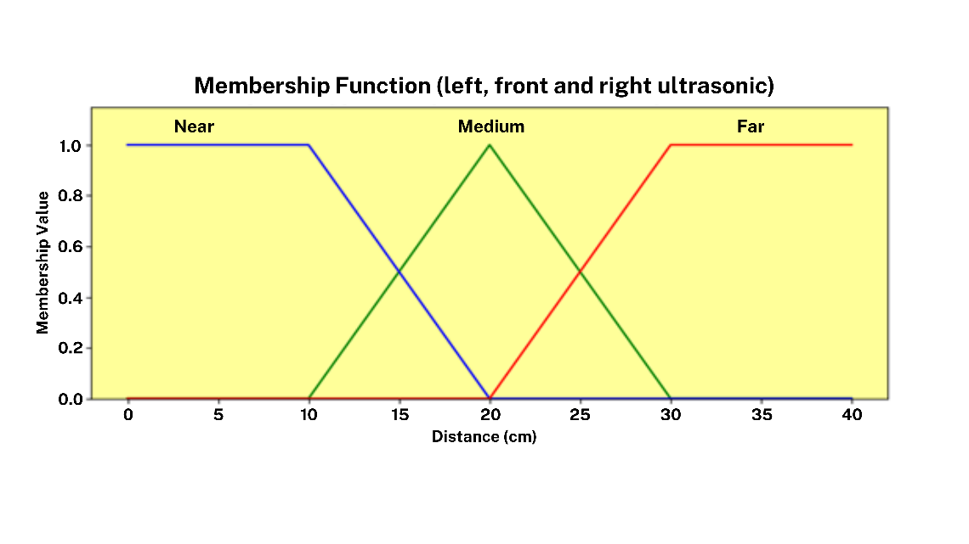

**Figure 2. Membership Function of Fuzzy Logic**

1. Inference (Rule Base)

These fuzzy rules can be changed or adapted to changing environmental or system conditions so that the fuzzy system can continue to adapt and provide optimal results. The fuzzy rule base of the Takagi-Sugeno-Kang model with reference is shown in Table 1.

**Table 1. Fuzzy rule base: Rules according to Fuzzy TSK ($if x_{1} is A_{i1}, x_{2} is A_{i2}, x_{3} is A_{i3}, then f_{i} is a_{i}$)**

|  |  |  |  |  |
| --- | --- | --- | --- | --- |
| **No.** | **Ultrasonik**  **Kiri** | **Ultrasonik**  **Depan** | **Ultrasonik**  **Kanan** | **Sudut (°)** |
| 1 | Near | Near | Near | -90 |
| 2 | Near | Near | Medium | -90 |
| 3 | Near | Near | Far | -90 |
| 4 | Near | Medium | Near | 0 |
| 5 | Near | Medium | Medium | 0 |
| … | … | … | … | … |
| 27 | Far | Far | Far | 0 |

1. Defuzzification

Defuzzification is an output membership function where the output of the Takagi-Sugeno-Kang fuzzy type is discrete or singleton. The output membership is in the form of angles divided into 90, 0, and -90, as in Figure 3.

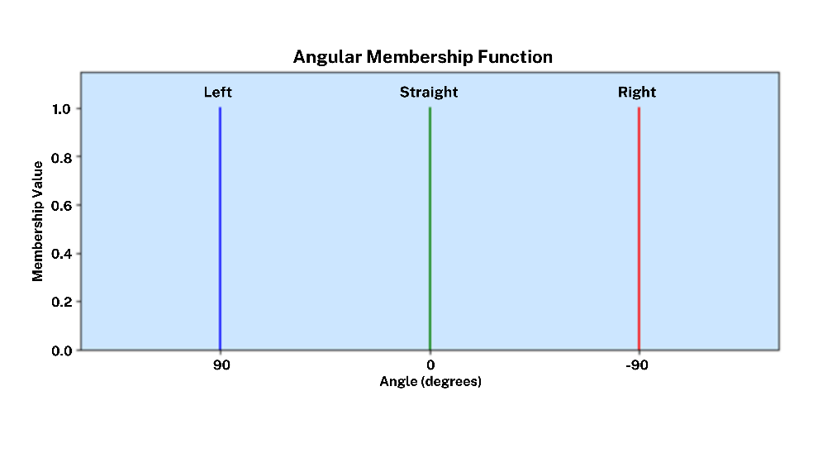

**Figure 3. Membership Function Output Fuzzy (Singleton)**

### Tuning PID using Ziegler-Nichols 2 Method

The Ziegler-Nichols oscillation method uses a trial and error approach to find Kp, Ti, and Td parameters. The steps for this oscillation method are as follows (Akbar, 2013):

1. Create a closed loop system by inserting controller P and plant into it.
2. Ki = 0 and Kd = 0, then the Kp value is increased from zero to the critical value Kcr, resulting in the system output experiencing continuous oscillations with a more or less consistent amplitude.

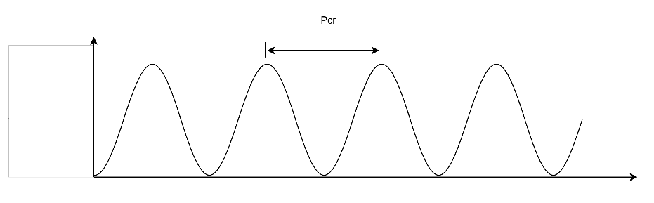

**Figure 4. Ziegler-Nichols Oscillation**

1. The critical gain Kcr and period Pcr can be determined based on the continuous oscillation output.
2. Calculate the Kp, Ti, and Td values as shown in Table 2 for the parameters of the Ziegler-Nichols oscillation method.

**Table 2. Ziegler Nichols 2 Table**

|  |  |  |  |
| --- | --- | --- | --- |
| **Type of Controller** | ***Kp*** | ***Ti*** | ***Td*** |
| P | $$0.5K_{cr}$$ | $$∞$$ | 0 |
| PI | $$0.45K_{cr}$$ | $$\frac{1}{1.2}P_{cr}$$ | 0 |
| PID | $$0.6K_{cr}$$ | $$0.5P_{cr}$$ | $$0.125P_{cr}$$ |

1. The Ki and Kd values are obtained using the following calculations:

|  |  |  |
| --- | --- | --- |
|  | $$Ki=\frac{Kp}{Ti}$$ | (1) |
|  | $$Kd=Kp×Td$$ | (2) |

### Implementation of Combining Fuzzy Logic and PID on a Mobile Robot

The workflow of the system combining fuzzy logic and PID systems shown in Figure 5 begins by initiating a set point for the angle of the IMU sensor as an initial reference for the robot's position. The IMU angle value will be determined by the ultrasonic sensor readings, which will detect surrounding objects, as illustrated in Figure 6.

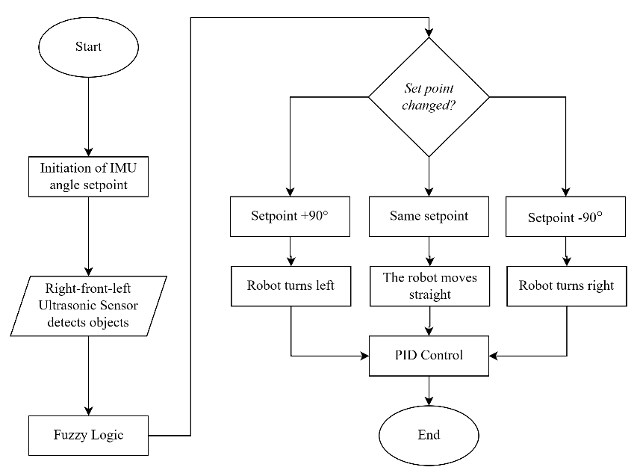

**Figure 5. Obstacle avoidance mobile robot workflow**

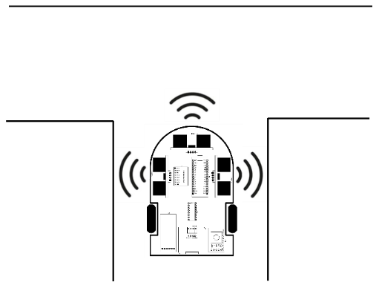

**Figure 6. Illustration of a mobile robot detecting objects**

Reading the distance between the robot and the object is an input value for fuzzy logic. Fuzzy logic functions to generalize the uncertainty of an object into a set member. The fuzzy logic output decides the angle value from the fuzzy calculation results. This angle value will determine the direction of the robot's movement so that the robot can avoid objects around it. The robot's movement at each set point will be stabilized by PID control.

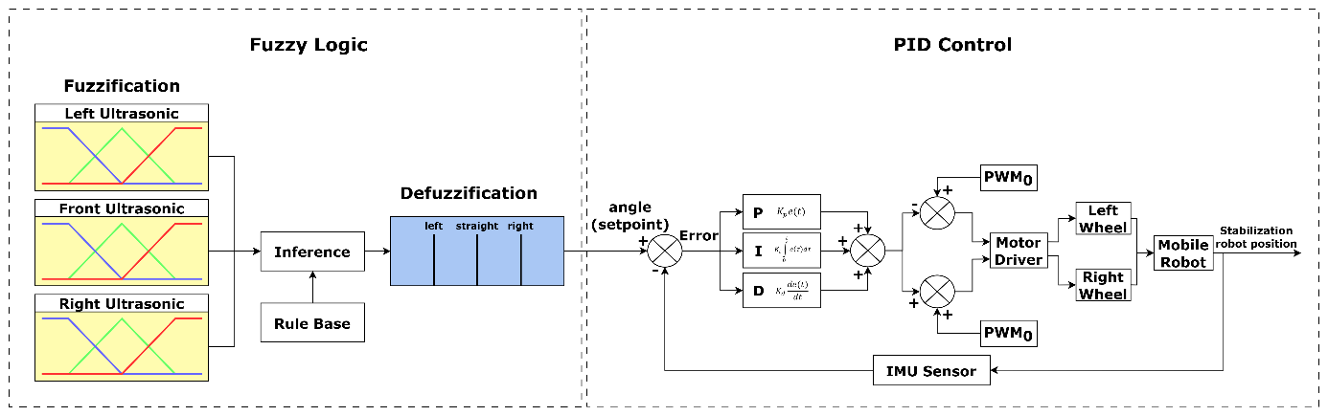

**Figure 7. Fuzzy-PID Block Diagram**

### Hardware Design

In this research, fuzzy logic and PID control systems will be studied by designing a tool in the form of a mobile robot, which is designed using a printed circuit board (PCB) with a circuit schematic and PCB design as shown in Figure (8) and (9).

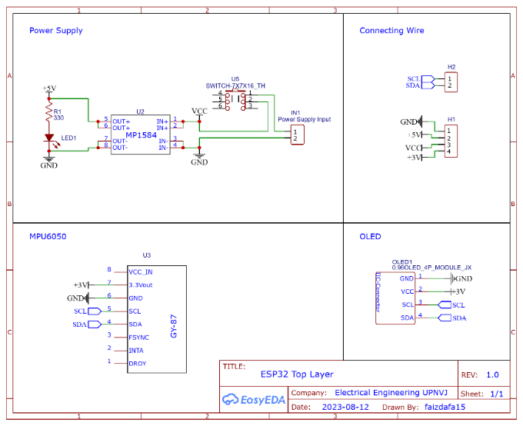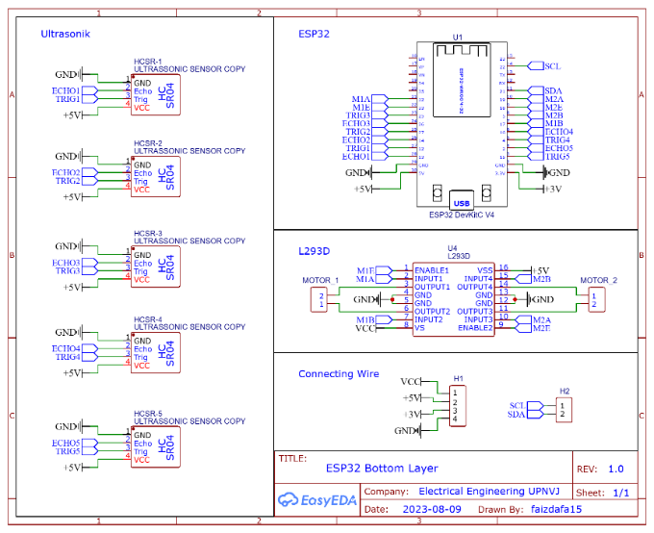

**(a) top schematic layout (b) bottom schematic layout**

**Figure 8. Schematic Diagram of Mobile Robot**

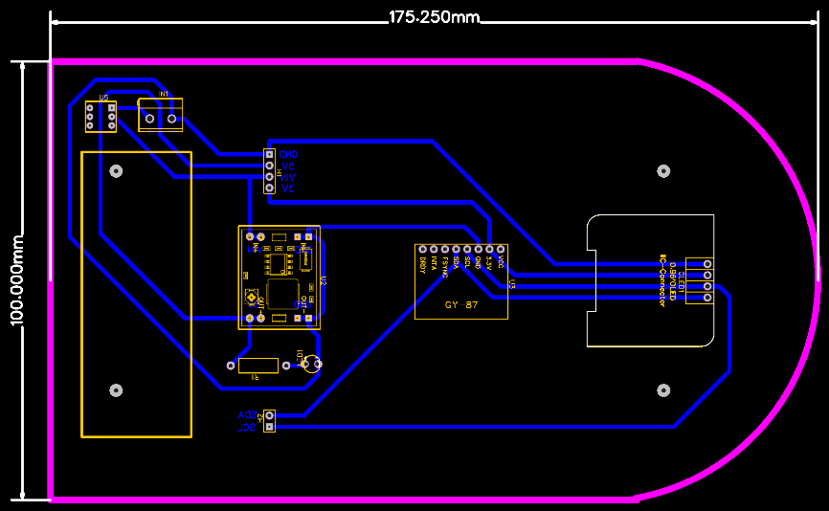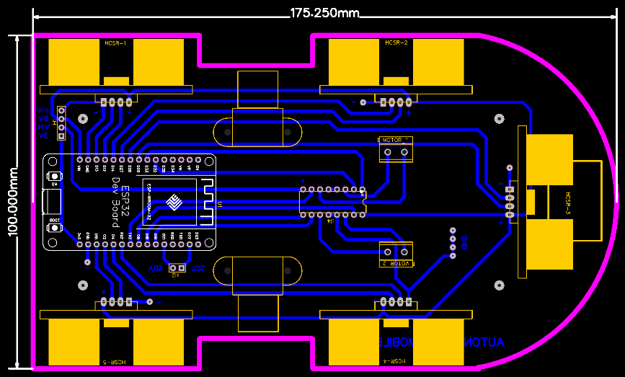

**(a) top PCB layout (b) bottom PCB layout**

**Figure 9. Mobile Robot PCB Design**

### Fuzzy logic evaluation technique

The data processing technique in fuzzy logic uses a confusion matrix because it can provide a clear picture of the performance of the classification system. Confusion matrices are widely applied in evaluating the performance of classifiers on datasets that can predict classes correctly and identify where the model could make mistakes. The four central cells of the confusion matrix, namely TP (True Positive), FP (False Positive), TN (True Negative), and FN (False Negative), are used for the classification of true and false classes (Hasnain et al., 2020; Markoulidakis et al., 2021).

**Table 3. Multiclass Confusion Matrix**

|  |  |  |  |  |  |
| --- | --- | --- | --- | --- | --- |
|  |  | Prediction Value | | | |
| Nilai Aktual |  | **C1** | **C2** | **…** | **C3** |
| Actual Value | **C1** | C1,1 | FP | … | C1,N |
| **C2** | FN | TP | … | FN |
| **…** | … | … | … | … |
| **C3** | CN,1 | FP | … | CN,N |

By analyzing these four central cells, we can calculate evaluation metrics, namely accuracy and precision, with the following calculations.:

$Accuracy=\frac{\sum_{i=1}^{N}{TP(C_{i})}}{\sum_{i=1}^{N}{\sum_{j=1}^{N}{C_{i,j}}}}$ (3)

${Precision}_{class}=\frac{TP(C_{i})}{TP(C_{i})+FP(C_{i})}$ (4)

## REFERENCES

Achmad, B., & Karsiti, M. N. (2007). Visual-based fuzzy navigation system for mobile robot: Wall and corridor follower. *2007 International Conference on Intelligent and Advanced Systems*, 244–248. https://doi.org/10.1109/ICIAS.2007.4658383

Akbar, A. E. (2013). Implementasi Sistem Navigasi Wall Following Menggunakan Kontroler PID Dengan Metode Tuning Pada Robot Kontes Robot Cerdas Indonesia (KRCI) Divisi Senior Beroda. *Jurnal Mahasiswa Teknik Elektro Universitas Brawijaya*, *1*(1), 114859. https://www.neliti.com/publications/114859/

Al-Mallah, M., Ali, M., & Al-Khawaldeh, M. (2022). Obstacles Avoidance for Mobile Robot Using Type-2 Fuzzy Logic Controller. *Robotics 2022, Vol. 11, Page 130*, *11*(6), 130. https://doi.org/10.3390/ROBOTICS11060130

Galin, R., & Meshcheryakov, R. (2019). Automation and robotics in the context of Industry 4.0: the shift to collaborative robots. *IOP Conference Series: Materials Science and Engineering*, *537*(3), 1. https://doi.org/10.1088/1757-899X/537/3/032073

Hasnain, M., Pasha, M. F., Ghani, I., Imran, M., Alzahrani, M. Y., & Budiarto, R. (2020). Evaluating Trust Prediction and Confusion Matrix Measures for Web Services Ranking. *IEEE Access*, *8*, 90847–90861. https://doi.org/10.1109/ACCESS.2020.2994222

Hellmann, M. (2001). Fuzzy Logic Introduction. *Universite de Rennes*, *1*(1).

Hu, W., Wang, K., Chen, H., -, al, Fauzi, R., Mustari, A., -, L., Albab, A. N., Rahmawati, E., Yantidewi, M., Sucahyo, I., & Firmansyah, R. R. (2020). Control Position of Mobile Robot Based on Odometry Method and PID Controller. *Journal of Physics: Conference Series*, *1491*(1), 012039. https://doi.org/10.1088/1742-6596/1491/1/012039

Markoulidakis, I., Rallis, I., Georgoulas, I., Kopsiaftis, G., Doulamis, A., & Doulamis, N. (2021). Multiclass Confusion Matrix Reduction Method and Its Application on Net Promoter Score Classification Problem. *Technologies 2021, Vol. 9, Page 81*, *9*(4), 81. https://doi.org/10.3390/TECHNOLOGIES9040081

Najmurrokhman, A., Kusnandar, K., Wibowo, B. H., & Amarullah, M. H. R. (2018). DESAIN PENGENDALI LOGIKA FUZZY TIPE TAKAGI-SUGENO-KANG UNTUK MENGATUR KECEPATAN GERAK MOBILE ROBOT. *Prosiding Semnastek*, *0*(0). https://jurnal.umj.ac.id/index.php/semnastek/article/view/3431